# Appendix I Homework #9 Lean Manufacturing

# Assembly of Chrysler Steering Column

**Purpose of Assignment** Gain experience and knowledge solving in an industrial problem using Lean Manufacturing fundamentals and your innovations talents. The solution will be at the concept level. Detailed drawings, bill of materials, specifications, etc. are not required. The concept solution should be described in sufficient detail to be understood and evaluated.

**Customer Wants**

1. Reduce Labor: in general, and in scanning of bar code and torquing bolt securing shaft to column.
2. Poka-Yoke (mistake-proofing): skim module used or not and correct shaft used (4x2 or 4x4) [Note: the 2 shafts are identical at the end that connects to the column which has a temporary pin which locks it at 0° angular position; the other end of both shafts is 4 sided but they differ by 45° ]

**The Assignment**

1. Quantify the amount of wasted time and motion by the workers and of the part/product by using Value Stream Mapping. (okay to work in teams to distribute the load, all members of the team should help, note your team members in report)
2. Write a report making suggestions for improving the column assembly operation. (note, this is an individual effort). Write the report not as a student completing a homework assignment but as an engineer at Chrysler to your boss or whomever at Chrysler requested this study on ways to improve the assembly of the steering column.

**Report Format and Grading** Be as clear and specific as possible.

**General Format** (8 pts) Typed with a cover page, main discussion section and a reference section with Value Stream Mapping data. The cover page should have: a descriptive title, author, date, course name, and summary. The summary on the cover page is important (4 of the 8 points); a boss in the industrial world is interested in what you did [studied, results] but they are usually more interested in what you recommend and why.

**Discussion-Wasted** **Time, Effort and Motion** (12 pts)* Discuss results of your Value Stream Mapping, state what the data indicates should be changed and why.

**Discussion-Suggestions** (60 pts) Make and explain your suggestions so a fellow engineer can understand them.

1. Labor improvement in general (12 pts)*

Suggestions: #3 needs more than “activate…so runs automatically” briefly state what an engineer would tell a designer to do, along the lines of what covered in Ch. 17, for #4&5 re-read Poke-Yoke in C’Notes Ch. 13 & 29 & Mistake Proofing in Ch. 29.

1. Labor improvement scanning of bar code (12 pts)*
2. Labor improvement torquing bolt securing shaft to column (12 pts)*
3. Poka-Yoke (mistake-proofing): SKIM** module used or not (12 pts)*
4. Poka-Yoke (mistake-proofing): correct shaft used (4x2, 4x4) (12 pts)*

**Discussion-Learning** (10 pts) As a result of your Value Stream Mapping

and this Industrial Homework assignment, explain what you now understand

about Lean Mfg., manufacturing operations and ways of improving them.

**Reference Section** with Value Stream Mapping Data. (10 pts)

*Note: 12 points, 10 points for soundness/practicality, amount of material, appropriate technical level and 2 points for the clarity of suggestion.

**SKIM=Sentry Key Immobilizer Module

**The Steering Column Sub-Assembly Operation**

* The operation is illustrated in the Video “Hwk #9 Lean Mfg-Steering Column” available on Canvas. In the video the operation is shown 3 times. First time-slow with narration, second time-slow close up, and third near normal speed. On the reverse side is a rough sequence of the tasks. This operation is “in-sequence” so later when the assembled steering column comes off the overhead conveyor it is matched with the vehicle it is to be installed on.
* I’ve tried to get a Steering Column from a dealer but it is a “safety” item which means the columns are registered with the government. When a column is replaced, a mechanic must go to the distributor to pick it up and must sign for it. If anything goes wrong on a steering column (other than air bag or horn button?) I was told they toss it and get a new one. Hence I couldn’t get a column as a demo.

See Ch. 29 for a sample of a filled in Value Stream Mapping form. A blank VSM form is included with this assignment, page J-3.

**- OVER -**

The following are my rough notes of what the operator does in this job.

1. Read monitor to see which shaft is used and if optional skim module is used.
2. Walk to, pickup column, carry and place column in the jig (fixture).
3. Step, reach, pick up and install the clock spring on the column.
4. Pickup anchor bolt, place it on the clock spring and hand tighten.
5. Remove the rubber band from the overdrive assembly, place wire onto clip, fold extra length of wire.
6. Walk to front of table, turn column shaft so the shaft hole is vertical.
7. Pickup and install on the column-the correct shaft.
8. Pickup and install the bolt in the thru hole on column and shaft.
9. Press 2 safety buttons to activate the clamps.
10. Grab electric nut runner, pull it down to the bolt, press torque switch, when full torque reached release torque switch, and release the nut runner tool (spring return).
11. Reach, pickup bar scanner, read column bar code, and put down scanner.
12. Pickup and install black ring.
13. If skim module required, go to, pickup scanner and module, scan module, set down scanner, go to end of column and install skim unit onto the column.
14. Press 2 safety buttons releasing the clamps.
15. Pickup column and carry it to and place on the conveyor.
16. Return to table, key into computer the column buildup is completed, checking on monitor that the key strokes are read in.
17. Pickup and place nut in jig.

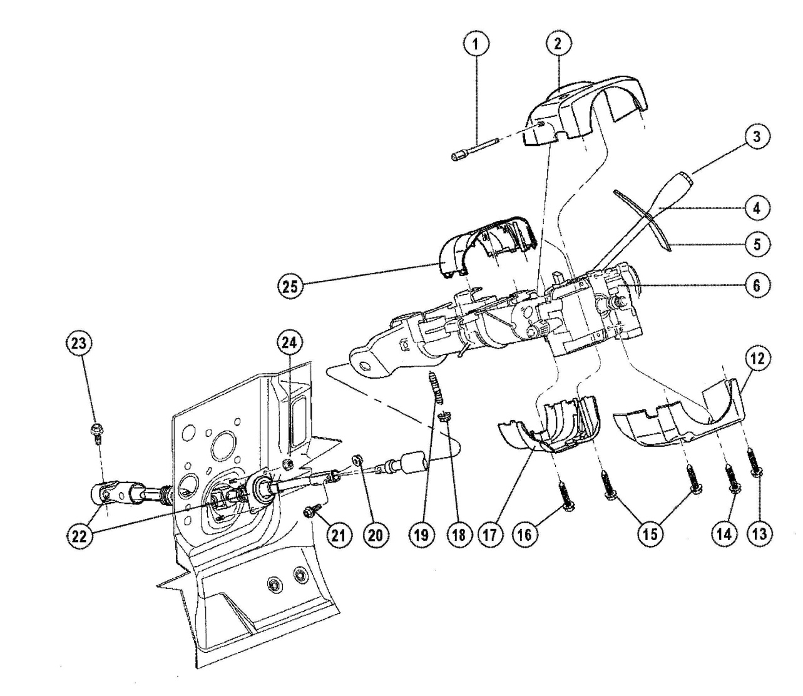

Value Stream Mapping Form

**Project Title:**_________________________

**Value Stream for** (check) **Person** **🞏** or **Part** **🞏**, **Name:**__________________________

**By:**_____________

**Date:**___________

|  |  |  |  |  |
| --- | --- | --- | --- | --- |
| **Activity-Task**  1.  a) (sub-activity/task) | **Value Adding?**  **(y/n)** | **Task Time** | **Time since last**  **Task completed** | Movement |
|  |  |  |  |  |
|  |  |  |  |  |
|  |  |  |  |  |
|  |  |  |  |  |
|  |  |  |  |  |
|  |  |  |  |  |
|  |  |  |  |  |
|  |  |  |  |  |
|  |  |  |  |  |
|  |  |  |  |  |
|  |  |  |  |  |
|  |  |  |  |  |
|  |  |  |  |  |
|  |  |  |  |  |
|  |  |  |  |  |
|  |  |  |  |  |
|  |  |  |  |  |
|  |  |  |  |  |
|  |  |  |  |  |
|  |  |  |  |  |
|  |  |  |  |  |
|  |  |  |  |  |
|  |  |  |  |  |
|  |  |  |  |  |
|  |  |  |  |  |
|  |  |  |  |  |
|  |  |  |  |  |
|  |  |  |  |  |
|  |  |  |  |  |
|  |  |  |  |  |
|  |  |  |  |  |
|  |  |  |  |  |
|  |  |  |  |  |
|  |  |  |  |  |
|  |  |  |  |  |
|  |  |  |  |  |
|  |  |  |  |  |
|  |  |  |  |  |

Intentional Blank Page